Estudo de Barh e Kumar em 2009, foi-nos possível visualizar a tabela com as enzimas citoplasmáticas essenciais na *N. gonorrhoeae* que não estão presentes no Homem (tabela 1).

**Tabela 1**. Enzimas citoplasmáticas essenciais em *N. gonorrhoeae* (potenciais “targets” para antibióticos) que não estão presentes no Homem a partir da via metabólica comum entre hospedeiro-patogéneo. (Adaptado de [1]).

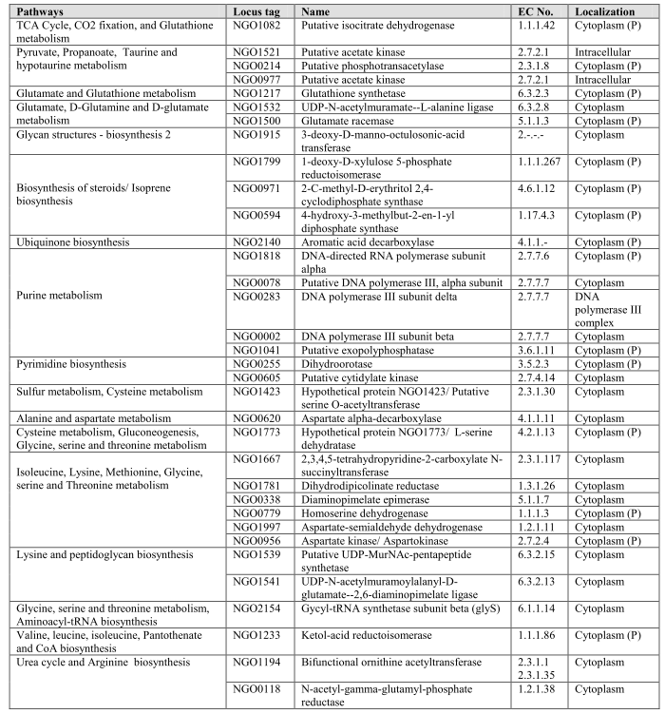

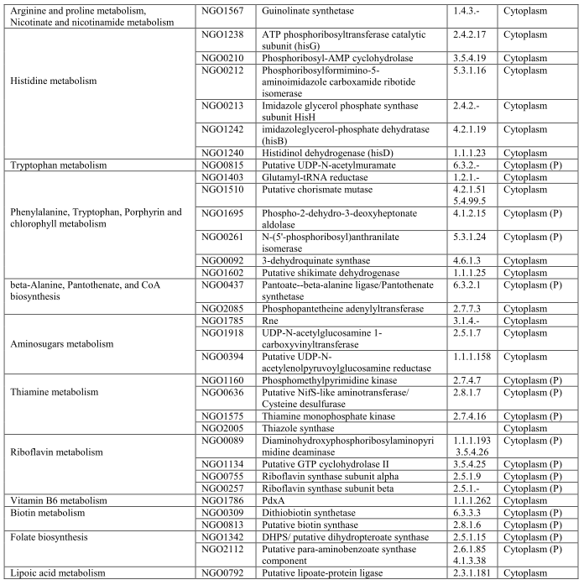

**Tabela 2.** Tabelas com os “targets” para vacinas a partir da via metabólica comum entre hospedeiro-patogéneo e dos “targets” para potenciais medicamentos e vacinas a partir da via metabólica única e específica do patogéneo. (Adaptado de [1]).

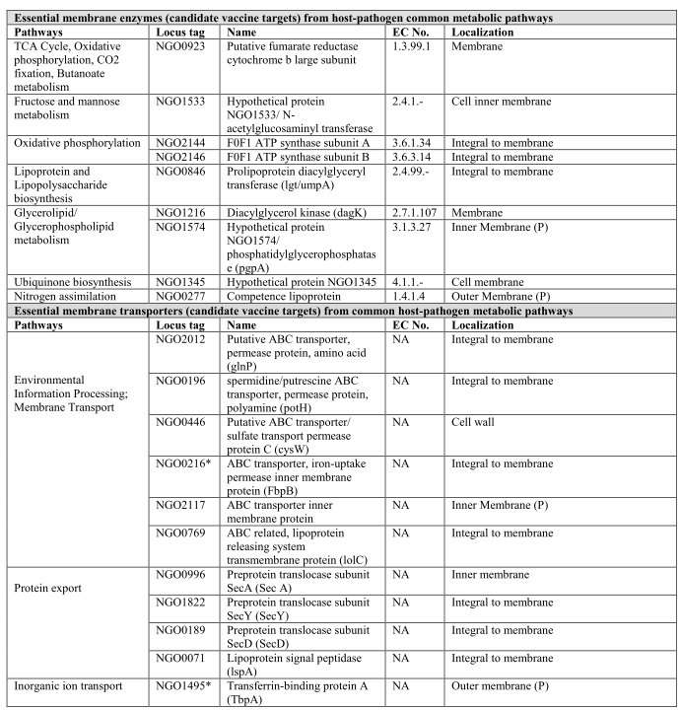

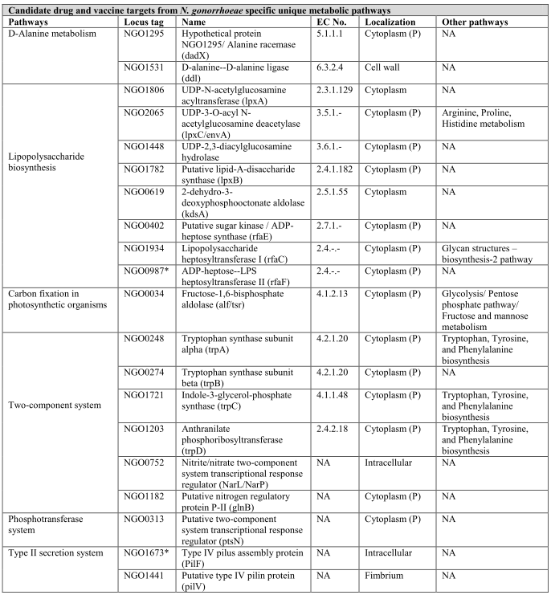

Enzimas citoplasmáticas essenciais (“targets” de antibióticos) (tabela 1)

Enzimas membranares essenciais (“targets” para vacinas) (tabela 2)

Transportadores membranares essenciais (“targets” para vacinas) (tabela 2)

“Targets” para medicamentos e vacinas (tabela2)

**Locus_tag Nome da proteina**

NGO1213 putative long-chain-fatty-acid--CoA-ligase

NGO1214 putative tRNA methyltransferase

NGO1215 conserved hypothetical protein

NGO1216 Putative diacylglycerol kinase

NGO1217 glutathione synthetase

NGO1218 putative glutaminyl-tRNA synthetase

NGO1219 putative DeoR-family transcriptional regulator

NGO1220 conserved hypothetical protein

NGO1221 putative GntR-family transcriptional regulator

NGO1222 conserved hypothetical protein

NGO1223 conserved hypothetical protein

NGO1224 putative phosphoribosylglycinamidetransformylase

NGO1225 putative peptidyl-prolylisomerase

NGO1226 putative DNA polymerase III chi subunit

NGO1227 putative aminopeptidase A

NGO1228 conserved hypothetical protein

NGO1229 conserved hypothetical protein

NGO1230 hypothetical protein

NGO1231 putative aconitate hydratase 2

NGO1232 ornithine carbamoyltransferase

NGO1233 putative ketol-acid reductoisomerase

NGO1234 conserved hypothetical protein

NGO1235 putative acetolactatesynthase isozyme III small subunit

NGO1236 putative acetolactate synthase isozyme III large subunit

NGO1237 conserved hypothetical protein

NGO1238 putative ATP phosphoribosyltransferase

NGO1239 conserved hypothetical protein

NGO1240 putative histidinol dehydrogenase

NGO1241 putative histidinol-phosphate aminotransferase

NGO1242 putative imidazoleglycerol-phosphate dehydratase

NGO1243 conserved hypothetical protein

NGO1244 putative MarR-family transcriptional regulator

NGO1245 conserved hypothetical protein

NGO1246 putative serine protease

NGO1247 putative CDP-diacylglycerol transferase

NGO1248 conserved hypothetical protein

NGO1249 conserved hypothetical protein

NGO1250 mtrCDE transcriptional regulator, activator

NGO1251 conserved hypothetical protein

NGO1252 conserved hypothetical protein

NGO1253 putative ABC transporter, periplasmic binding protein, polyamine

NGO1254 putative alanyl-tRNA synthetase

NGO1255 conserved hypothetical protein

NGO1256 putative insertion element IS1016 transposase

NGO1257 hypothetical protein NGO1257

NGO1258 2,3-bisphosphoglycerate-dependent phosphoglycerate mutase

NGO1259 DNA topoisomerase IV subunit A

NGO1260 putative transcriptional regulator

NGO1261 Ribosomal RNA small subunit methyltransferase J

NGO1262 putative invertase related gene 5, putative phage associated protein

NGO1263 conserved hypothetical protein, putative phage associated protein

NGO1264 conserved hypothetical protein, putative phage associated protein

NGO1265 putative TspB-like protein

NGO1266 conserved hypothetical protein, putative phage associated protein

NGO1267 conserved hypothetical protein, putative phage associated protein

NGO1268 conserved hypothetical protein, putative phage associated protein

NGO1269 conserved hypothetical protein, putative phage associated protein

NGO1270 conserved hypothetical protein, putative phage associated protein

NGO1273 conserved hypothetical protein

NGO1274 conserved hypothetical protein

NGO1275 putative nitric oxide reductase

NGO1276 nitrite reductase

NGO1277 conserved hypothetical protein

NGO1279 conserved hypothetical protein

NGO1282 conserved hypothetical protein [Neisseria gonorrhoeae FA 1090]

NGO1283 putative phosphoserine aminotransferase [Neisseria gonorrhoeae FA 1090]

NGO1284 conserved hypothetical protein [Neisseria gonorrhoeae FA 1090].

NGO1285 putative N utilisation substance protein A [Neisseria gonorrhoeae FA;1090]

NGO1286 putative translation initiation factor IF-2 [Neisseria gonorrhoeae FA 1090]

NGO1287 conserved hypothetical protein [Neisseria gonorrhoeae FA 1090]

NGO1288 conserved hypothetical protein [Neisseria gonorrhoeae FA 1090]

NGO1289 conserved hypothetical protein [Neisseria gonorrhoeae FA 1090]

NGO1290 putative amino-acid transporter, sodium/alanine symporter [Neisseria gonorrhoeae FA 1090]

NGO1291 conserved hypothetical protein

NGO1292 putative disulfide bond formation protein

NGO1293 hypothetical protein NGO1293

NGO1294 putative AsnC-family transcriptional regulator

NGO1295 putative alanine racemase

NGO1296 hypothetical protein NGO1296

NGO1297 conserved hypothetical protein

NGO1298 conserved hypothetical protein

NGO1299 conserved hypothetical protein

NGO1300 conserved hypothetical protein

NGO1301 hypothetical protein NGO1301

NGO1302 putative insertion element IS1016 transposase

NGO1304 DNA-binding competence protein 2

NGO1306 hypothetical protein NGO1306

NGO1307 putative flavoprotein

NGO1308 putative guanosine-3',5'-bis(diphosphate)3'-pyrophosphohydrolase

NGO1309 putative RNA polymerase, omega subunit

NGO1310 putative guanylate kinase

NGO1311 putative adenine phosphoribosyltransferase

NGO1312 conserved hypothetical protein

NGO1313 conserved hypothetical protein [Neisseria gonorrhoeae FA 1090]

NGO1314 putative protease [Neisseria gonorrhoeae FA 1090]

NGO1315 conserved hypothetical protein [Neisseria gonorrhoeae FA 1090]

NGO1317 putative insertion element IS1016 transposase [Neisseria gonorrhoeae FA 1090]

NGO1318 conserved hypothetical protein [Neisseria gonorrhoeae FA 1090]

NGO1319 putative paraquot-inducible protein A [Neisseria gonorrhoeae FA 1090]

NGO1320 putative paraquat-inducible protein B [Neisseria gonorrhoeae FA 1090]

NGO1321 conserved hypothetical protein [Neisseria gonorrhoeae FA 1090]

NGO1322 putative DNA-3-methyladenineglycosylase I [Neisseria gonorrhoeae FA 1090]

NGO1323 conserved hypothetical protein [Neisseria gonorrhoeae FA 1090]

NGO1324 conserved hypothetical protein

NGO1325 putative glycine dehydrogenase

NGO1327 conserved hypothetical protein

NGO1328 putative cytochrome

NGO1329 putative amino acid aminotransferase

NGO1330 putative tRNA (uracil-5-)-methyltransferase

NGO1331 putative chorismate synthase

NGO1332 conserved hypothetical protein

NGO1333 putative DNA topoisomerase IV subunit B

NGO1334 putative invasion protein

NGO1335 putative seryl-tRNA synthetase

NGO1336 putative dehydrogenase, lactate

NGO1337 putative peptide chain release factor I

NGO1338 conserved hypothetical protein

NGO1339 putative L-asparaginase

NGO1340 conserved hypothetical protein

NGO1341 putative phosphoglucomutase protein

NGO1342 putative dihydropteroate synthase

NGO1343 conserved hypothetical protein

NGO1344 conserved hypothetical protein

NGO1345 conserved hypothetical protein

NGO1346 conserved hypothetical protein

NGO1347 conserved hypothetical protein

NGO1348 hypothetical protein NGO1348

NGO1349 conserved hypothetical protein

NGO1350 hypothetical protein NGO1350

NGO1352 putative 3-oxoacyl-(acyl-carrier-protein) synthase

NGO1353 putative beta-1,4-glucosyltransferase

NGO1354 putative alpha-1,2-N-acetylglucosamine transferase

NGO1355 putative sodium dependent ion transport protein

NGO1357 putative thymidylate synthase B

NGO1358 putative glutamate dehydrogenase

NGO1359 hypothetical protein NGO1359

NGO1360 putative GntR-family transcriptional regulator

NGO1361 conserved hypothetical protein

NGO1362 conserved hypothetical protein

NGO1363 multidrug efflux pump channel protein

NGO1364 antibiotic resistance efflux pump component

NGO1365 antibiotic resistance efflux pump component

NGO1366 mtrCDE transcriptional regulator, repressor

NGO1367 conserved hypothetical protein

NGO1368 antibiotic resistance efflux pump component

NGO1369 putative exodeoxyribonuclease V

NGO1370 conserved hypothetical protein

NGO1371 putative cytochrome c oxidase subunit

NGO1372 conserved hypothetical protein

NGO1373 putative cytochrome c oxidase subunit

NGO1374 putative cytochrome c oxidase subunit

NGO1375 conserved hypothetical protein

NGO1376 conserved hypothetical protein

NGO1377 transport protein

NGO1378 transport protein

NGO1379 TonB

NGO1380 conserved hypothetical protein

NGO1381 putative glutaredoxin 2

NGO1382 putative GTP pyrophosphokinase

NGO1383 conserved hypothetical protein

NGO1384 conserved hypothetical protein

NGO1385 conserved hypothetical protein

NGO1386 conserved hypothetical protein

NGO1387 hypothetical protein NGO1387

NGO1388 hypothetical protein NGO1388

NGO1389 hypothetical protein NGO1389

NGO1390 hypothetical protein NGO1390

NGO1391 hypothetical protein NGO1391

NGO1392 putaputative MafB-like protein

NGO1393 putative MafA-like protein

NGO1394 putative insertion element IS1016 transposase

NGO1395 conserved hypothetical protein

NGO1396 putative electron transfer flavoprotein-ubiquinone oxidoreductase

NGO1397 putative dissimilatory nitrous oxide reduction protein, lipoprotein

NGO1398 putative dissimilatory nitrous oxide reduction protein, membrane protein

NGO1399 putative ABC transporter, ATP-binding protein

NGO1403 putative glutamyl-tRNA reductase

NGO1404 putative glycine cleavage system component H

NGO1405 hypothetical protein NGO1405

NGO1406 putative aminomethyltransferase

NGO1407 putative AsnC-family transcriptional regulator

NGO1408 conserved hypothetical protein

NGO1410 conserved hypothetical protein

NGO1411 conserved hypothetical protein

NGO1412 putative insertion element IS1016 transposase

NGO1413 putative Na(+)-translocating NADH-ubiquinone reductase subunit A

NGO1414 putative Na(+)-translocating NADH-ubiquinone reductase subunit B

NGO1415 putative Na(+)-translocating NADH-ubiquinone reductase subunit C

NGO1416 putative Na(+)-translocating NADH-ubiquinone reductase subunit D

NGO1417 putative Na(+)-translocating NADH-ubiquinone reductase subunit E

NGO1418 putative Na(+)-translocating NADH-ubiquinone reductase subunit F

NGO1419 hypothetical protein NGO1419

NGO1420 putative thiamine biosynthesis protein

NGO1421 conserved hypothetical protein

NGO1422 putative heat shock protein

NGO1423 putative serine O-acetyltransferase

NGO1424 putative ubiquinone biosynthesis protein

NGO1426 conserved hypothetical protein

NGO1427 putative transcriptional regulator, repressor

NGO1428 conserved hypothetical protein

NGO1429 putative heat shock protein

NGO1430 hypothetical protein NGO1430

NGO1431 hypothetical protein NGO1431

NGO1432 hypothetical protein NGO1432

NGO1433 putative ABC transporter, permease protein

NGO1434 putative ABC transporter, ATP-binding protein

NGO1435 putative cadmium resistance protein

NGO1437 putative primosomal protein N'

NGO1438 onserved hypothetical protein

NGO1439 putative ABC transporter, ATP-binding protein

NGO1440 putative ABC transporter, periplasmic protein

NGO1441 putative type IV pilin protein

NGO1442 putative alcohol dehydrogenase

NGO1443 conserved hypothetical protein

NGO1444 hypothetical protein NGO1444

NGO1445 hypothetical protein

NGO1446 hypothetical protein

NGO1447 hypothetical protein

NGO1448 UDP-2,3-diacylglucosamine hydrolase

NGO1449 putative L-lactate permease

NGO1450 conserved hypothetical protein

NGO1451 conserved hypothetical protein

NGO1452 putative aspartate aminotransferase

NGO1454 putative lysyl-tRNA synthetase

NGO1455 conserved hypothetical protein

Damos crédito ao grupo 7, pois foram eles que encontraram este ótimo artigo e que nos mostraram o mesmo, de modo a melhorarmos a qualidade do nosso trabalho.

Bibliografia:

1. Barh, D. and A. Kumar, *In silico identification of candidate drug and vaccine targets from various pathways in Neisseria gonorrhoeae.* In Silico Biol, 2009. **9**(4): p. 225-31.